**OpenWorm C. elegans robotics**

Tom Portegys1,3, Shane Gingell2,

1OpenWorm Foundation, Boston MA, USA; 2Out of the BOTS, Nambour, Queensland, Australia; 3EY Consulting, Seattle, WA, USA

**Keywords:** Robotics, Computational Biology, *Caenorhabditis elegans*

Summary

One of the goals of the OpenWorm project is to promote awareness of the biology of the C. elegans nematode worm. In the robotics subproject, this takes the form of creating physical implementations of the worm which approximate prevalent scientific models. The downside of this is that C. elegans is, of course, not a robot. However, simulating the worm in robotic form manifests a tangible aspect that pure software models do not possess. However, dealing with the actual worm, a transparent 1mm organism, requires special conditions and equipment, such as lighting and microscopes. Another aim of the robotics effort is to foster crossover education in biology, robotics, and coding. This might take the form of either specifying or producing kits of parts that can be assembled by students in school settings or by generally interested parties. This paper discusses other biological robotics efforts and describes in detail the latest OpenWorm robot produced in conjunction with *Out of the BOTS* robotics.

1. Introduction

The OpenWorm project’s stated goal is the creation of a virtual C. elegans. In a true spirit of scientific and technical curiosity, however, it can be viewed as an umbrella of initiatives that both further this primary aim but also support a number of secondary goals and activities. The education committee is chartered with promoting education about computational biology using C. elegans as a model subject, for example. The robotics subproject in turn aims to produce a robotic worm that can be assembled and programmed by students and other interested parties. This combines coding, robotics, and computational biology and is intended to serve as a classroom learning project.

Another purpose of the robot project is to be able to encounter and solve problems that often are not visible to, or are easily bypassed by entirely simulated solutions. And in doing so suggest possible biological mechanisms within C. elegans. For example, in designing a mechanism for food foraging, one must take into account that the worm senses salt gradients as it moves in its environment [1]. Although it is not entirely clear how this works in the worm, a method that senses a signal gradient in a moving robot has triggered ideas about further biological research on this topic.

The noted physicist Richard Feynman famously wrote, "What I cannot create, I do not understand". There is an invaluable back-and-forth flow of ideas and insights between analysis and synthesis. For example, the invention of the steam engine helped discover thermodynamics principles. In a robotic implementation, there are factors such as friction, noise, and in general analog irregularities that are in some ways more in kinship with a physical body, even one made of animal tissue, than a pure simulation.

The biological roboticist Jeff Krichmar puts it this way: ‘The often used phrase, ‘‘understanding through building’’, implies that one can get a deep understanding of a system by constructing physical artifacts that can operate in the real-world. In building and studying neurobiologically inspired robots, scientists must address theories of neuroscience that couple brain, body, and behavior.’ [2]. Arguments from the field of Artificial Intelligence can also be brought to bear here, where robotics researchers such as Brooks [3], Hoffmann and Pfeifer [4] have opined that true authenticity can only be achieved by machines that have sensory and motor skills and are connected to the world through a body.

Furthermore, the National Science Foundation’s Special Report on Robots and Biology [5] reports that, “Evolution has produced a wide range of intelligent, mobile sensor units in the form of living organisms ranging from insects to humans. Compared to current robots, insects and other animals often have much more flexible and efficient control of their movements. Some researchers study organisms to develop better robots, while others build robots to better understand the organisms.” Numerous projects are leveraging nature to guide the development of robotics. For example, an interdisciplinary team of researchers is using a grant to study how the complex movements of octopuses can be used to design a bio-inspired, soft-armed, autonomous robot [6].

Considering the educational rationale of the robotic C. elegans, robots as classroom projects are gaining popularity and credibility as approaches for studying technology and science, integrating activities that explore technological models of scientific phenomena. To explain difficult abstract concepts in science and math subjects, teachers are using robotics kits that include various types of robots, including quadcopters, robotic arms, etc. [7]. Cuperman and Verner [8] have implemented this in a method where a learner inquires into a biological phenomenon and develops its representation in the form of a robotic model.

The C. elegans robot was demonstrated as part of a public program of events associated with the conference that was hosted by OpenWorm at the Sainsbury Wellcome Centre for Neural Circuits and Behaviour in London, UK on January 31st 2018.

A short video of the robot in action can be viewed here: <https://www.youtube.com/watch?v=z1zARL2_4oM>

# 2. Description

The following sections describe the design and implementation of the robot at the time of the conference demonstration and features that are proposed for future versions. The current implementation is a combined effort of the authors. Gingell spearheaded the design and initial build and Portegys built the version used for the demo as well as supplying software to run the simulation. Future collaborations might include other interested parties.

The 3D models, code, and parts list are available at: <https://github.com/openworm/robots>

### Current version

**Hardware**

Figure 1 shows a top view of the robot with major components denoted. Figure 2 shows a side view. The robot consists of 9 articulated segments, each segment mounted on a pair of wheels. Locomotion is achieved, as it is in C. elegans, by moving in a snakelike manner that relies on surface friction. The wheels are hence not powered and exist to provide a suitable contact surface with the ground. Each segment is a 3D printed component that articulates with its neighbors via servos. The electronic components are mounted on platforms fastened to several of the segments. The Raspberry Pi Zero W (RPi) is a full-fledged microprocessor that included wireless communication capability. A PWM board distributes power and controls signals from the RPi to the servos. Each servo is capable of maintaining a specified angular position that translates to inter-segment angular positioning.

# 

Figure 1 – Top view of robot.

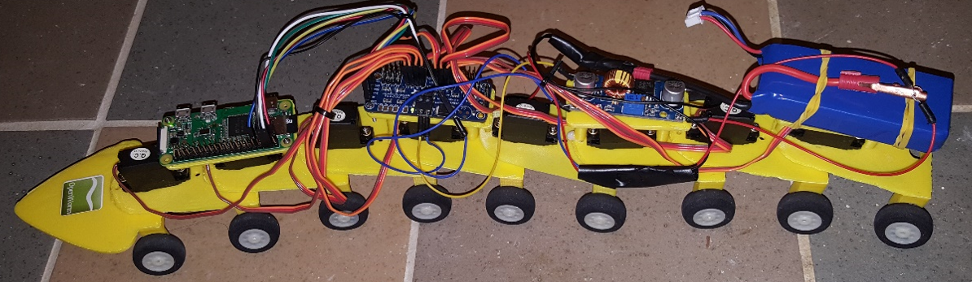

Figure 2 – Side view of robot.

Figure 3 shows the designs for the three 3D printed parts. These parts are specified in a common .stl file format that is editable and portable to most 3D printers. On the left is the segment part. In the center is the head that is envisioned to be mounted with sensors for food foraging and touch. On the right is one of the platforms for mounting the electronic components.

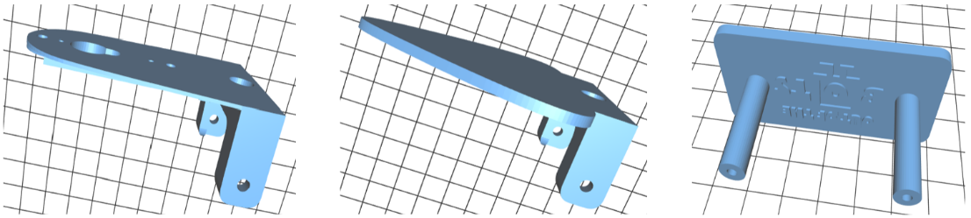

Figure 3 – 3D printed body parts.

Figure 4 shows how the segments are articulated. A servo is mounted on the front top of the segment with its geared shaft extending into an aperture in the next forward segment. An arm secured to the gear sits in a recession in the segment that transfers the angular movement of the gear into angular movements between the segments.

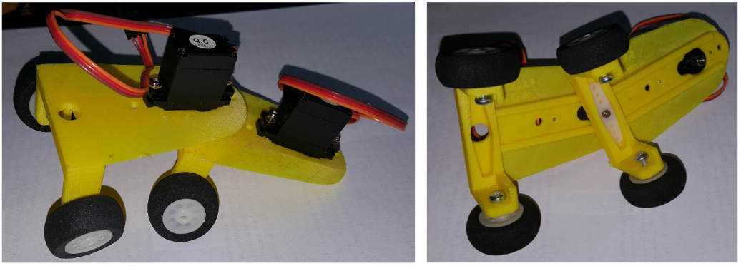

Figure 4 – Segment subassembly.

###### Programming and control

## For the current implementation, the RPi replays a recorded sequence of segment angle positions partially shown in Figure 5. Each line is processed at a set interval of time, and the angles are directly distributed to the servos. It can be seen that the anterior segments receive signals or greater magnitude than the posterior segments. The overall effect is to achieve an undulating forward motion.

[78,-0.63,-0.65,-0.62,-0.58,-0.55,-0.51,-0.48,-0.44,-0.41,-0.37,-0.34,-0.30],

[219,-0.63,-0.65,-0.62,-0.58,-0.55,-0.51,-0.48,-0.44,-0.41,-0.37,-0.34,-0.30],

[375,-0.63,-0.65,-0.62,-0.58,-0.55,-0.51,-0.48,-0.44,-0.41,-0.37,-0.34,-0.30],

[531,0.63,0.00,-0.62,-0.58,-0.55,-0.51,-0.48,-0.44,-0.41,-0.37,-0.34,-0.30],

[672,0.63,0.65,-0.62,-0.58,-0.55,-0.51,-0.48,-0.44,-0.41,-0.37,-0.34,-0.30],

[812,0.63,0.65,0.00,-0.58,-0.55,-0.51,-0.48,-0.44,-0.41,-0.37,-0.34,-0.30],

[937,0.63,0.65,0.62,-0.58,-0.55,-0.51,-0.48,-0.44,-0.41,-0.37,-0.34,-0.30],

[1047,0.63,0.65,0.62,0.00,-0.55,-0.51,-0.48,-0.44,-0.41,-0.37,-0.34,-0.30],

[1156,0.63,0.65,0.62,0.58,-0.55,-0.51,-0.48,-0.44,-0.41,-0.37,-0.34,-0.30],

[1344,0.63,0.65,0.62,0.58,0.55,-0.51,-0.48,-0.44,-0.41,-0.37,-0.34,-0.30],

[1515,-0.63,0.65,0.62,0.58,0.55,0.51,-0.48,-0.44,-0.41,-0.37,-0.34,-0.30],

[1672,-0.63,0.65,0.62,0.58,0.55,0.51,0.00,-0.44,-0.41,-0.37,-0.34,-0.30],

[1781,-0.63,0.00,0.62,0.58,0.55,0.51,0.48,-0.44,-0.41,-0.37,-0.34,-0.30],

[1906,-0.63,-0.65,0.62,0.58,0.55,0.51,0.48,-0.44,-0.41,-0.37,-0.34,-0.30],

[2031,-0.63,-0.65,0.62,0.58,0.55,0.51,0.48,0.44,-0.41,-0.37,-0.34,-0.30],

[2140,-0.63,-0.65,0.00,0.58,0.55,0.51,0.48,0.44,-0.41,-0.37,-0.34,-0.30],

[2265,-0.63,-0.65,-0.62,0.58,0.55,0.51,0.48,0.44,0.41,-0.37,-0.34,-0.30],

[2375,-0.63,-0.65,-0.62,0.58,0.55,0.51,0.48,0.44,0.41,0.37,-0.34,-0.30],

[2547,-0.63,-0.65,-0.62,-0.58,0.55,0.51,0.48,0.44,0.41,0.37,0.34,0.30],

[2656,-0.63,-0.65,-0.62,-0.58,0.55,0.51,0.48,0.44,0.41,0.37,0.34,0.30],

[2875,0.63,-0.65,-0.62,-0.58,-0.55,0.51,0.48,0.44,0.41,0.37,0.34,0.30],

Figure 5 – Sample recorded angular movement data.

The data is recorded from an off-line run of a simulation of the worm developed by Boyle, Berri, and Cohen [9]. This simulation is a fine-grained model of the worm’s neuromuscular system that achieves locomotion. Unfortunately the simulation entails a computation-intensive physics engine that is too demanding for the RPi, hence the need for the recording/replay operations. An Android phone app is also available that contains the simulator functionality [10].

The recording is transferred to the RPi via the *scp* (secure copy) command. To run the robot, the user logins in via *ssh* and executes a Python script that initializes the servos and processes the recorded file line-by-line. The script is available on GitHub at <https://github.com/openworm/robots>

### (b) Future versions

A number of new features are planned for the future. These include:

* Food foraging and touch response.
* A new system-on-a-board processor that will also perform power and control distribution.
* Laser-cut segments.
* Real-time movement control from the simulator via http to the RPi.
* A Python Notebook [] that will provide a programming interface to the robot. This can also support software exercises related to C. elegans, such as how the neural network can be optimized to achieve sensorimotor coordination for touch response, for example.

The robot will also be productized, meaning that at a minimum a complete list of parts and assembly instructions produced that will allow someone with moderate technical skills to build the robot. A more ambitious plan is to pre-order and box the parts for single purchase availability.

## 3. Summary

We have presented a robotic version of C. elegans that is intended to adhere to and demonstrate the biology of the worm as closely as possible. Future versions, likely implementing food foraging and touch response, will continue this design goal. We hope to produce a robot kit that is suitable for students to learn about the fascinating biology of the worm as well as to hone skills in robotics and coding.

Additional Information

**Information on the following should be included whenever relevant.**

**Acknowledgments**

We would like to acknowledge the OpenWorm community and contributors for their support and interest in the robot project.

**Data Accessibility**

The computer code and 3D model files are available on GitHub at <https://github.com/openworm/robots>

**Authors' Contributions**  
Gingell designed and built the initial robot, including the 3D printed parts. Portegys reproduced the design and provided software for running the simulation that produces run data for the robot. Portegys wrote the initial draft of the paper which was subsequently revised and polished by both authors.

**Competing Interests**

We have no competing interests.

**Funding**

No external funding sources were used to write this paper. Purchases of parts for the robot were made by the authors.

References

1. Izquierdo, E. and Beer, R. D. (2015). "[An Integrated Neuromechanical Model of Steering in C. elegans](https://mitpress.mit.edu/sites/default/files/titles/content/ecal2015/978-0-262-33027-5-ch040.pdf)", *ECAL15*.
2. Krichmar, J.L., Conradt, J., and Asada, M. (2015). “Neurobiologically Inspired Robotics: Enhanced Autonomy through Neuromorphic Cognition”. *Neural Networks*, 72, 1-2.
3. Brooks, R. (1999). Cambrian Intelligence: The Early History of the New AI. Cambridge MA: The MIT Press.ISBN 0-262-52263-2.
4. Hoffmann, M. and Pfeifer, R. (2011). “The implications of embodiment for behavior and cognition: animal and robotic case studies”, in W. Tschacher & C. Bergomi, ed., 'The Implications of Embodiment: Cognition and Communication', Exeter: Imprint Academic, pp. 31-58.
5. Website: <https://www.nsf.gov/news/special_reports/robotics/robots.jsp>
6. Fisher, R., et al. (2017). “Octopus-Inspired Autonomous Arms for Soft Robots with Adaptive Motions,” Office of Naval Research grant. <http://phoenixmed.arizona.edu/about/news/researchers-study-biology-octopuses-develop-autonomous-robots>
7. Schwartz, K. (2014). “Robots in the Classroom: What Are They Good For?” <https://www.kqed.org/mindshift/35611>
8. Cuperman, D. and Verner, I. M. (2013). “Learning through creating robotic models of biological systems”, *International Journal of Technology and Design Education,* Volume 23, Issue 4, pp 849–866.
9. Boyle, J., Berri, S., and Cohen, N. (2012). “[Gait modulation in C. elegans: an integrated neuromechanical model](http://www.frontiersin.org/Computational_Neuroscience/10.3389/fncom.2012.00010/abstract)”, *Front. Comput. Neurosci*.
10. Website: <http://wormworx.portegys.com/>